MEDIA RELEASE – BOCCE AUSTRALIA
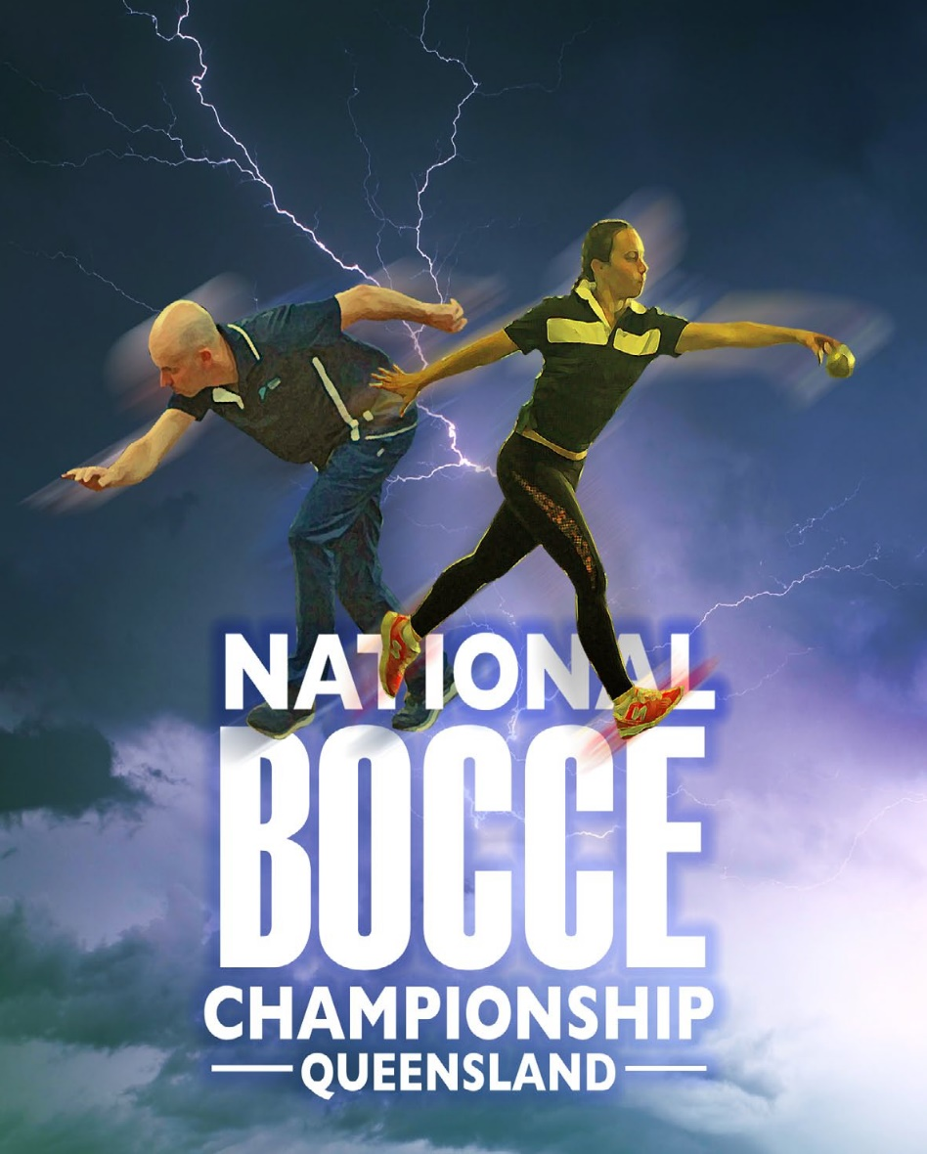
SPARKS WILL FLY IN QUEENSLAND AT THE
AUSTRALIAN BOCCE CHAMPIONSHIP –
AT THE REDLANDS
SPORTING CLUB
8TH to the 11TH of June 2018

The 48th Senior Bocce Championship and 23rd Women’s Bocce Championship this year will be a winner.
The Australian Bocce Championships this year has attracted 22 men and women teams all of which will be contesting for 12 titles. Players from all states and regions will compete over the four days, 8 to 11 June, at the Redlands Sporting Club Bocce-Drome.

The men will be competing in six medal events. The traditional Singles, Doubles, Triples, then the specialised Bowl Throw and the Precision and Progressive Throw competitions. The women will follow, competing in the traditional Singles, Doubles, Triples and Precision event.

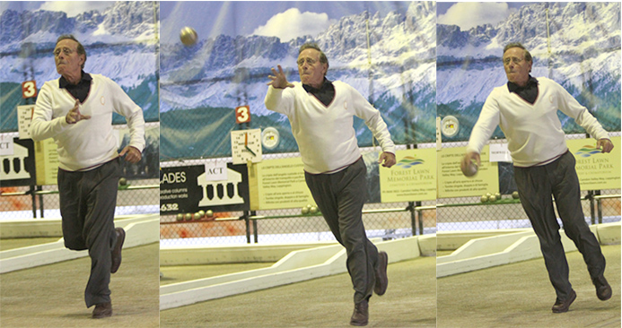
A stand out amongst the competitors will be Bundaberg’s Across the Waves Club patriarch, Lou Masotti, an icon in the sport whose long list of career highlights include representing Australia, winning back to back Doubles Championships and claiming the 2005 national crown, as well as taking home the best and fairest award and again in 2013 winning gold in the Singles!

Their main competitors include, Queensland Redlands Sporting Club international bronze medallist, Anthony Parlato, back into action after a few years absence from the game. The other bocce veteran from Western Australia Velimir Matutinovich (WA) will be trying hard to replicate his Australian Open Singles title of 2016. Victoria has perhaps the strongest depth in dependable players and is considered a threat in all events with power teams from Morwell, NEBA, Vic Metro including Victorian players representing the Nat U35’s. They are, Tony Borelli (Tatura, Vic) current Australian Champion in the Singles and Precision Throw, along with Dino Mikolic – Australian Bowl Throw champion and the Vic Metro team of Angelo Parisi, Tony Palermo and Jim Coviello with wild card entry Sasha Prostran. NSW on the other hand have the X-factor, as all eyes will be on Daniel Samsa (NSW) current World Bronze medallist from the Men’s World title last October, in the Bowl Throw event and current Australian and Oceania Progressive Throw Champion and record holder with a score of 42. He will boost the NSW Metro team and is sure to produce some great competition. Tasmania after a magnificent Australian Masters Games, will be competitive, as will the teams from South Australia, Cooma(ACT) and the National Under35’s.
Amongst the women the international Queenslander, Barbara Jones, in front of her home crowd, will be all out to regain her Singles and Precision throw titles. Western Australia will be competitive as always, as will be South Australia. Victoria will again be the power as the women’s teams from Morwell, NEBA and Vic Metro will again be strong and tuff to beat. NSW current Singles Champions Antonietta Ruscio with her NSW team mates will be a force on the courts which will bring out the best of strategy and skills, as the teams do battle to win the medals.

Preliminary Competition commences on Thursday afternoon with the inaugural National Club championship, between the Sydney power club, Club Marconi and the Victorian bocce stronghold of the Lazio-Marche club. Bothe clubs won the right to compete at this inaugural National Club Championship, after having won their home State Club Title. It should be a display of strategy, skill and high-octane speed as both clubs will be vying to be crowned the first Champion Bocce Club of Australia.

On Friday the Senior National Titles get underway and continues through till Monday 11th June at 6pm. The finals of most events will be completed on the Monday, concluding with the exciting Progressive Throw final at 5pm. The Championships are organised by the Bocce Federation of Australia with the support of the Australian Sports Commission, Queensland Bocce Federation and host club, the Redlands Sporting Club.

---------------------------------------------------END MEDIA RELEASE-------------------------------------------------

Location: Redlands Sporting Club, Wellington Point, Anson Rd. Qld. 4160. Phone 07) 3207 1133
Information contact: Bocce Australia Frank Funari 0417 339 640 or frankfunari@gmail.com
Qld. Contact: For player information and photo opportunities Neil Parlato 0408 378 672

