Bocce Australia Media Release:

Asia-Oceania Sport Boules Confederation is born!

On Saturday 28th April 2018, in the presence of:
Frank Funari Bocce Australia, President and Meeting Chairperson
Kobayashi Hirofumi Delegate Continental d’Asie de la F.I.B. and Japan Petanque Boules Federation
Li Shan Chinese Multi Bowls Association, Director
Wang Shu Chinese Multi Bowls Association, Translator
Anthony Biancacci Bocce Australia, Treasurer and Technical Director
Vince Di Mauro Bocce Australia Secretary
Lina Cher Bocce Australia, National Women’s Director
Sandra Samsa Bocce Australia, Minute Secretary
The Chinese Bowling Association, the Japanese Petanque Boules Federation and the Australian Bocce Federation were the inaugural signatories to the historic and newly formed Asia-Oceania Sport Boules Confederation. The signing of the constitution, was the confirmation of the birth of a new association to join the family of the World sport bocce governing body - the Federation International de Boules. It also reflects a partnership between the three countries which are bound by geography and deep ties of history and friendship.
This marks the beginning of a new era in the sport of bocce, as the FIB now has the structure in place covering all continents as part of the qualification to World Titles and hopefully one day to the Olympics. The Asia-Oceania Sport Boules Confederation joins the Pan-American Sport Boules Confederation, the European Boules Confederation and the African Boules Confederation to form a strong bond for future growth for the sport of bocce.
The concept of a confederation was initiated at the FIB Congress in 2015 and gathered momentum at the Congress in Morocco in 2017. It was the goodwill and collaboration of Mr. Frank Funari - Bocce Australia President, Mr. Kobayashi Hirofumi - Delegate Continental d’Asie de la F.I.B. and Japan Petanque Boules Federation and the Chinese Multi Bowls Association, that had the will and foresight to put in place the Asia-Oceania Sport Boules Confederation.
All three countries demonstrated good will and preparedness to compromise, resulting in a collaborative outcome that all parties were unanimously delighted with the outcome. As the inaugural three nations, they form the bulk of the governance for the next two years. As other Asian and Oceania nations join the confederation they too will be part of the association as they all help spread the sport of bocce to all corners of Asia and Oceania.
With the agreement reached the First Committee was duly elected with:
- Mr. Anthony Biancacci - President,
- Mr. Kobayashi Hirofumi - Vice-President and
- Ms. Wang Shu – Executive Board councillor.
- Also nominated to the board were Vince DiMauro as Treasurer and Frank Funari as Secretary.

Anthony Biancacci – inaugural President of Asia Oceania Sport Boules Confederation stated:
“I have thought about this previously and I am ambitious to get this Confederation up and running. This is long overdue, so we really need to develop this a lot further and expand the Asia/Oceania membership. I am happy to be President and I will uphold everything here and establish a relationship with all the surrounding countries as I am also eager to establish a dialogue with the current members and encourage them to be a part of us. I am happy and honoured to accept this position.”

The Bocce Australia President and Chair of the meeting, Mr. Frank Funari said: "The outcome is a milestone for the sport of bocce in the Asia and Oceania region. It reinforces the respect for, and the importance of, growing the sport on the international stage. It will provide boundless opportunities for Bocce players and Bocce sport enthusiast to enjoy all forms of competitions in years to come."
Mr. Funari went on to mention that “History is made today as the Sport of Boules establishes, for the first time, an Asia and Oceania group that will help to expand the sport in the region and provide the sporting opportunities for Elite competition as pathway to qualification to the World Titles. We thank the FIB for their patience, wisdom and trust, and the three inaugural country representatives for their constructive engagement and spirit of cooperation. This moment provides hope for the growth of the sport around the world and especially within the Asia and Oceania region."
Australia, China and Japan all expressed their gratitude to the five eminent Commissioners of the newly formed sporting Confederation, led by President Anthony Biancacci, for their great dedication and professionalism in helping to forge this agreement.
Below the Asia-Oceania Sport Boules Confederation logo designed by Mr. Kobayashi Hirofumi.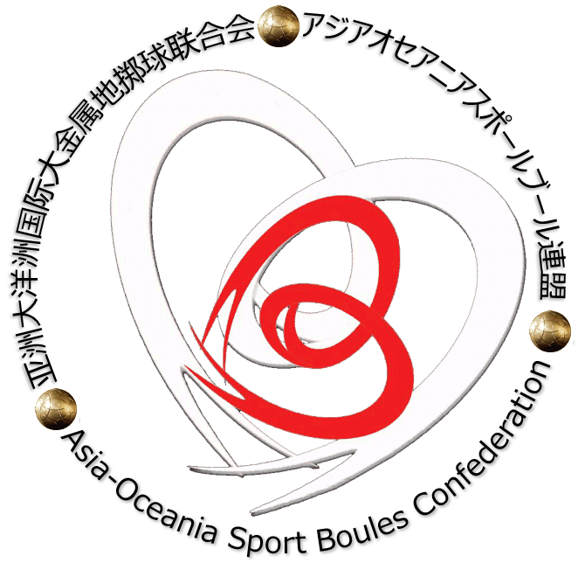
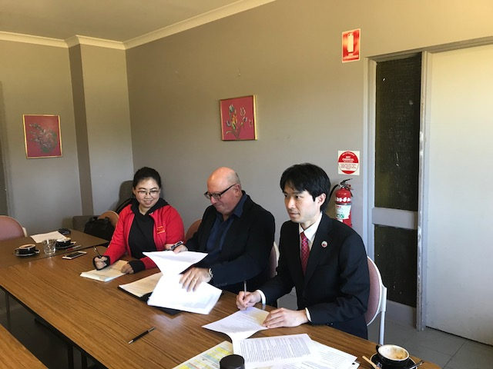
Signing the agreement L-R: Ms. Wang Shu – Executive Board councilor, Mr. Anthony Biancacci – President and Mr. Kobayashi Hirofumi - Vice-President

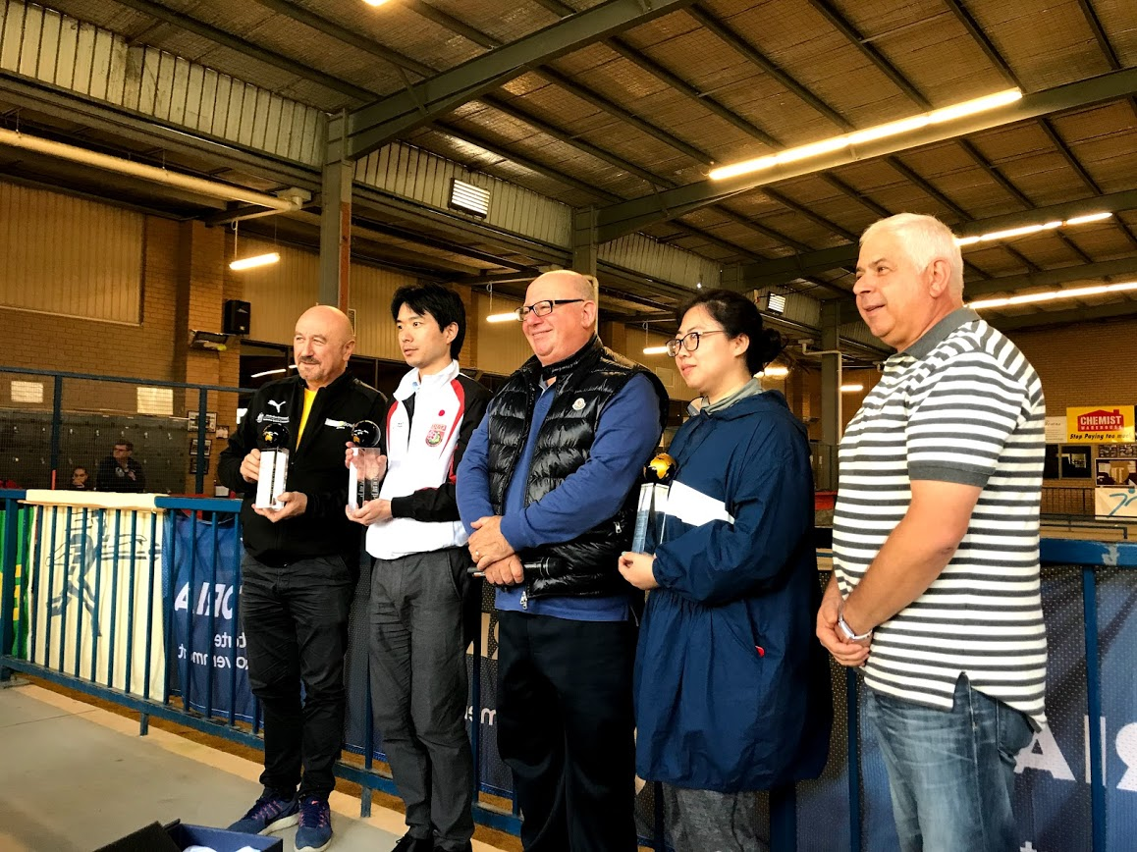
The 5 newly elected commissioners of the Asia Oceania Sport Boules Confederation L-R: Mr. Frank Funari, Mr. Kobayashi Hirofumi - Vice-President, Mr. Anthony Biancacci – President, Ms. Wang Shu – Executive Board councilor and Mr.Vince DiMauro.

------------------------------------------------End Media Release-----------------------------------

Media enquiries
- Bocce Australia - Frank Funari: 0417 339 640

