Bocce Federation of Australia

PO BOX 937, South Melbourne

Victoria 3205 Australia

ABN
24 703 226 127

Tel:
+61 0417 339 640

info@bocceAustralia.com.au

M E D I A R E L E A S E
Contact:  Sonia Fava  0476 333 900  For interviews & photograph opportunities | Frank Funari  M: 0417 339640  E: Info@bocceaustralia.com.au  W: www.bocceaustralia.com.au

FOR IMMEDIATE RELEASE

___________________________START MEDIA RELEASE____________________________

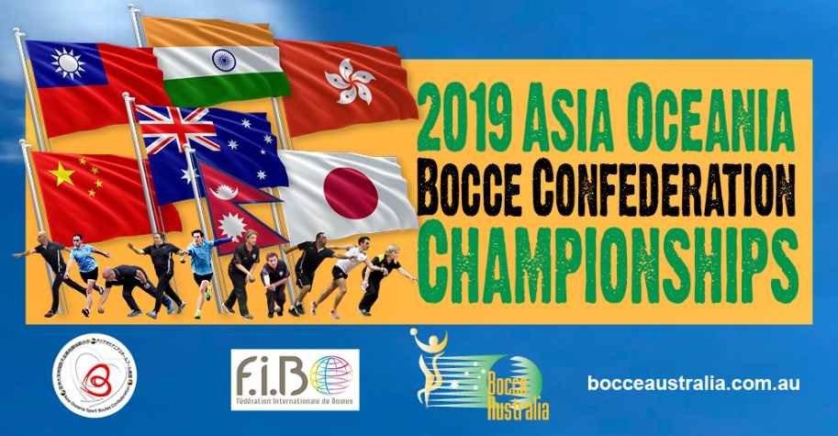
Many volunteers help to keep the balls rolling at this the first Asia Oceania Bocce Championships, in Melbourne
While the athletes prepare for next week’s Championship, coaches are drawing up their final game plans as the spectators will be in force to cheer from the stands, but it will be the many volunteers that are hard at work making sure Asia Oceania Bocce Championships 2019 are an incredible success.
Many people of all ages, abilities, nationalities and backgrounds have donated their time to being part of this the largest bocce sporting event of the year and the biggest event of its kind, since 1979, when last the World Doubles were last hosted in Melbourne.
These volunteers come from all corners of Australia and perfectly represent the diversity and community spirit at the heart of the Bocce Sport community.
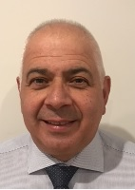
Vince DiMauro said he stepped forward to be part of the AO Bocce Championships so he can give back to the community, develop his sport administration skills, and draw on the determination of the athletes.
“We’re not here to volunteer only,” said Vince. “We here to leave our finger prints, draw smiles on their faces, solve some of their issues and cheer for their accomplishments.”
Vince, who was assigned the role of Volunteer Co-ordinator Director for these Championships, added “ ….that events such as the Asia Oceania Bocce Championships help to build friendships between people of many nations and diversity of cultures”. Vince said to BA “…The team have been working tirelessly for some months now, as we have been preparing for this big event next week and it is all coming together nicely in readiness for a great 3 days of Bocce Sport” .
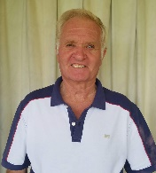
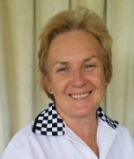
Neil and Maria Parlato, from Brisbane, jumped at the opportunity to volunteer at the Asia Oceania Bocce Championships, as Neil said to BA “ ….This was too big an opportunity to miss. I love the sport of Bocce and when asked to help out in the Officiating, both Maria and myself were honored to have been asked to help”.

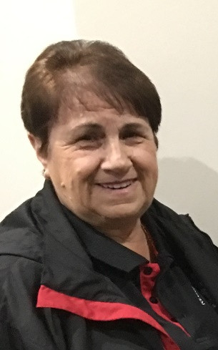
Likewise Mary Pagani, from Morwell Victoria said “I came here to support and give all I have as it’s important to give and serve your community, not take,” added Mary, who is keen to watch the Aussie girls especially the two from her local Morwell Club - Maria Maselli & Anna Prezioso in action.
There are so many other stories, why many other volunteers have come forward to give up their time – the photographers, catering co-ordinators, Referee’s, Tournament Directors, the transport drivers, the clock timers, scorers and overall general helpers. Over the next week we will hear more from these hard working bocce crew. These are the real hero’s that work tirelessly in the back ground to ensure that a Championship is a success. Bocce Australia is so proud of the many people that help make bocce sport roll on weekly but have stepped up to help make this event a success.
Below are just some of our many volunteers
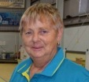
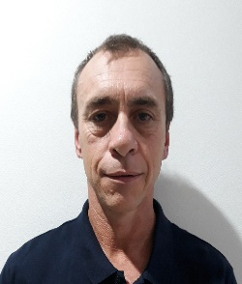
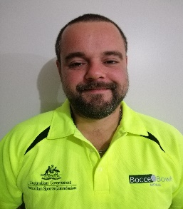
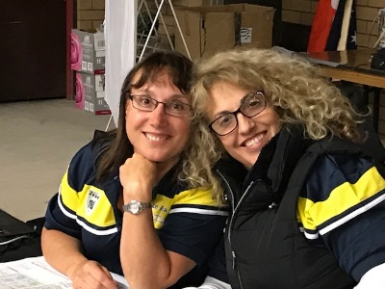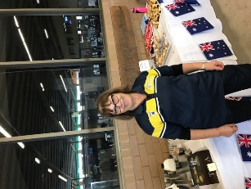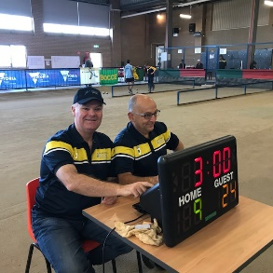

________________________END MEDIA RELEASE________________________________

