Bocce Federation of Australia

PO BOX 937, South Melbourne

Victoria 3205 Australia

ABN
24 703 226 127

Tel:
+61 0417 339 640

info@bocceAustralia.com.au

M E D I A R E L E A S E
Contact:  Sonia Fava  0476 333 900  For interviews & photograph opportunities | Frank Funari  M: 0417 339640  E: Info@bocceaustralia.com.au  W: www.bocceaustralia.com.au

FOR IMMEDIATE RELEASE

___________________________START MEDIA RELEASE____________________________

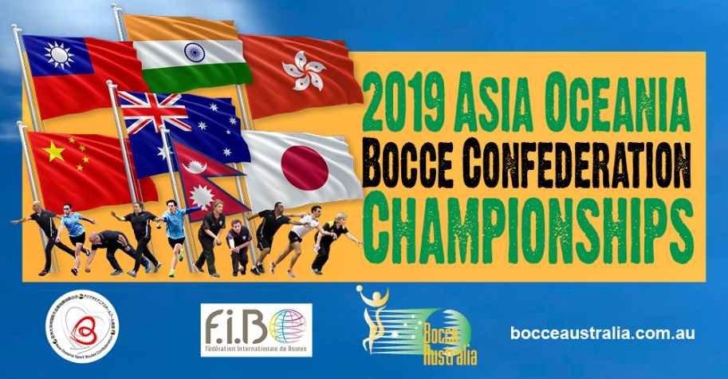
Western Australian Rosetta Kusevic first woman bocce player from Perth to represent Australia in the Asia Oceania Bocce Championships
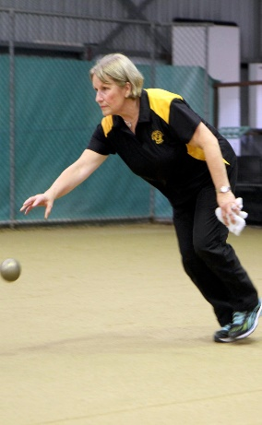
Rosetta Kusevic who qualified in 2018 by winning the Women’s Singles Championships has been selected by the Bocce Australia to represent the Australian team participating in the Asia Oceania Bocce Championship being conducted by Bocce Australia in Melbourne from May 3rd to May 5th. Rosetta is the first woman player to represent the Western Australia state in any bocce sport international competition. Rosetta who has been training at the Perth - Laguna Veneto Bocce club with the help of her husband, also a fine bocce player, is looking forward to this opportunity to wear the Green & Gold.
Rosetta Kusevic in action.
Photo by Raymond Cher
Athletes from countries in Asia and Oceania are set to descend into Melbourne, Casa D’Abruzzo Club Boccedrome from 3rd May to 5th May, to compete in the inaugural 2019 Asia Oceania Men’s & Women’s Bocce Championships.
The number of athletes allowed to compete in the seven disciplines of the sport of bocce have been decided and teams have been preparing for this opportunity for some past months. The traditional events of Singles, Doubles, BowlThrow along with the spectacular throwing events of Precision Throw, Progressive throw and Rapid Throw will be joined with the all new exciting Mixed Rapid Relay event.
The top two placegetters in each of the men’s & women’s divisions per discipline will qualify and earn the spot to go to the World Bocce Sport Championships to be hosted in Lyon France in November 2019.

________________________END MEDIA RELEASE________________________________

